**DAILY ONLINE ACTIVITIES SUMMARY**

|  |  |  |  |  |  |  |  |
| --- | --- | --- | --- | --- | --- | --- | --- |
| **Date:** | **22 July 2020** | | | | **Name:** | **Sinchana K N** | |
| **Sem & Sec** | **4th sem, 2nd year** | | | | **USN:** | **4al18cs083** | |
| **Online Test Summary** | | | | | | | |
| **Subject** | | **---** | | | | | |
| **Max. Marks** | | **--** | | **Score** | | **---** | |
| **Certification Course Summary** | | | | | | | |
| **Course** | Python Data Structure | | | | | | |
| **Certificate Provider** | | | **Coursera** | **Duration** | | | **19 hrs** |
| **Coding Challenges** | | | | | | | |
| **Problem Statement: python program** | | | | | | | |
| **Status: executed** | | | | | | | |
| **Uploaded the report in Github** | | | | **Yes** | | | |
| **If yes Repository name** | | | | Lockdown_coding1  <https://github.com/keertanaganiga/lockdown_reports> | | | |
| **Uploaded the report in slack** | | | | **Yes** | | | |

#### Online class: Today “How to develop Pythonic coding rather than Python coding” was conducted from 11:00-1:30 PM. Which contains two sessions.

#### Certification Course Summary:

#### Today I continued new course in Coursera, Python Data Structure which is of 19 Hrs course.

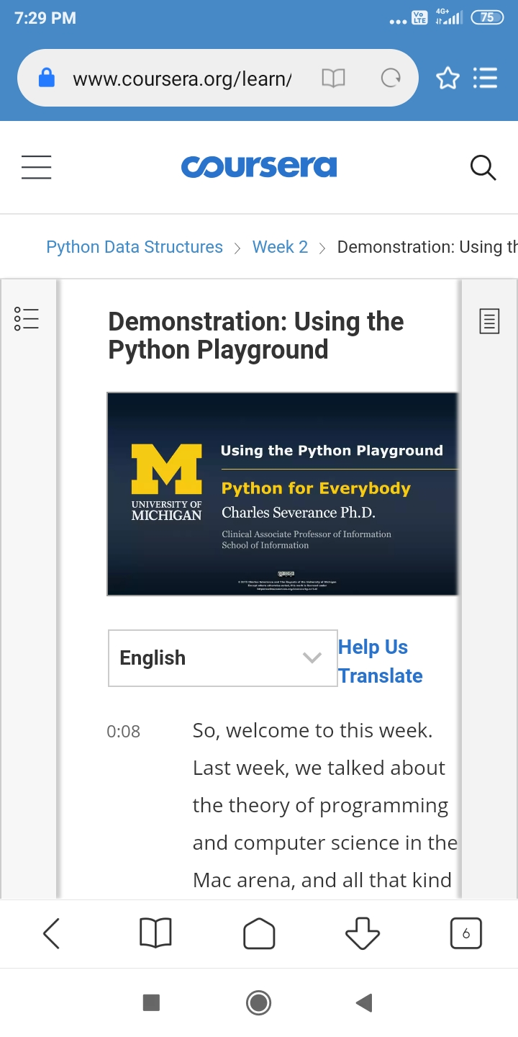

**Online coding:**Today I had attended the Workshop organized by AIET. The Workshop was on ‘ How to develop pythonic coding rather than python coding – Logic Perspective’ done by Dr. S Mohideen Badhusha CSE Dept. There was also Hands-on session through google colab.